**Changing the Mailing Address**

1. Change the mailing address in PACS
   1. Go to the Owner & Agent panel.
   2. Open the Taxpayer detail.
   3. Click on Properties in the left hand column to see what parcels will be changed with this update. If there are more than this parcel and you determine that they should all be changed proceed to the next step and add the new address. If you determine that all the parcels should not be changed, you will need to assign a new owner i.d. to this parcel (see the instructions under the Miscellaneous section at the end of this document then proceed to step 2. Enter an Event Note).
   4. Exit out of the Properties screen. Go back into the Taxpayers detail. Click on the green + to add the new address.
   5. Click on the drop down arrow under Address Type, choose M1(Mailing), and fill in the new information using the appropriate lines.
   6. Make this is the primary mailing address by clicking in the Mailing Address field above the Mail Returned information box:

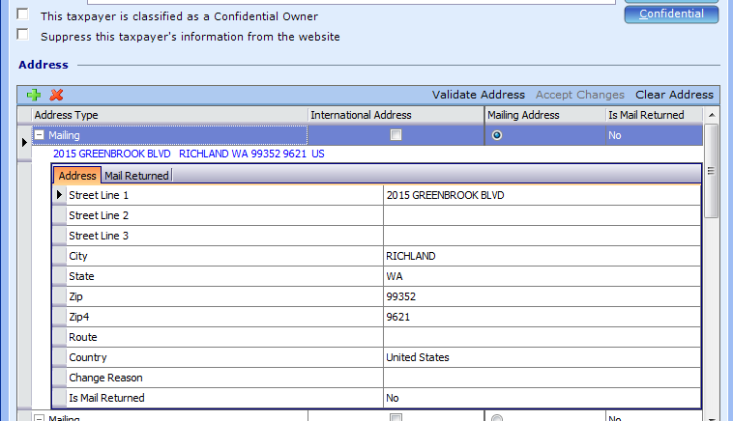

* 1. Click on the Save button at the top of the PACS screen.

1. Enter an Event Note
   1. Go to Events. Click on the green + to create a new event.
   2. Choose A-ADDRESS CHG.
   3. In the Description field enter today’s date and a note such as ‘changed address per _____’. End the comment with your initials.
   4. In the Event Objects section attach the document the created the address change. Do this by scanning or saving the document to your computer. Then in the event note click on the green + under Event Objects. Locate the document and click Open. (Once you have attached the document to the event note you can delete it from your computer.)
   5. Click Apply and OK.

**Miscellaneous**

1. If you notice that there is a senior exemption on the parcel, please give the notice to Marlena.
2. Assigning a new owner i.d. to a parcel:
   1. In the Owner & Agent panel under the Taxpayers section, click on Change (in the same banner where you will see the magnifying glass). The Property Ownership Wizard will open:

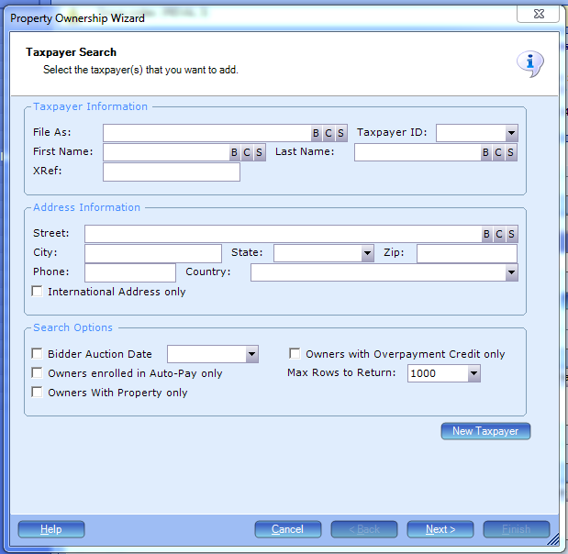

* 1. Click on New Taxpayer and enter details to create new taxpayer. The File As field should start with the last name then the first name(s) with no comma and in all upper case letters. Fill in the address information. When complete, click on Create at the bottom of the screen.

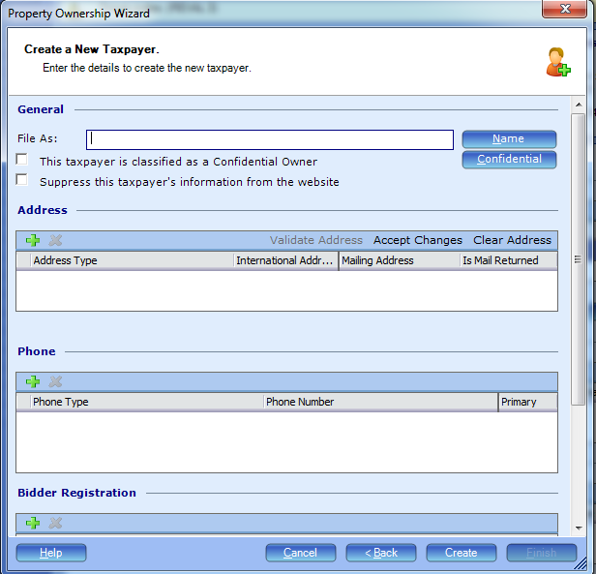

NOTE: Address changes should only be done if there is authorization from the taxpayer such as an address change form or email.